I believe that Special Landscape Areas should be designated across all of South Warwickshire.

This designation was removed from the Warwick District Local Plan in 2006 based on the claim that the policies in the adopted Local Plan sought to refuse development which would have a detrimental impact on the attractive landscape character and open nature of the Special Landscape Areas.
It was considered that the objectives of previous SLA policies, and the protection that they gave to these areas, would be equally well covered within the policy framework of the new Local Plan. The policy also drew attention to the broad extent of the Special Landscape Areas identified by the Structure Plan and should have ensured that these sensitive areas were afforded proper protection.

Unfortunately, the removal of the Special Landscape Area designation has meant that it is no longer obvious which land used to fall into this category and has resulted in the ability for such land to be put forward as a site for consideration in the Call for Sites. Any piece of land that is, or used to be, within a Special Landscape Area should have been automatically rejected.

Specifically, the area in Kenilworth between Rouncil Lane and Farm Road / Oaks Farm as shown below:

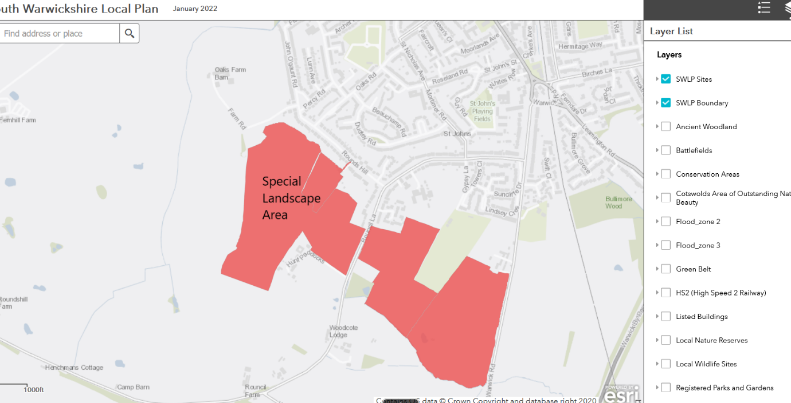

The area consists of Grade 3 agricultural land, being made up of existing parcels of farmland which are separated by hedgerows and trees. Historically, this land was part of the Arden Special Landscape Area and is located wholly within the Green Belt. Being on the side and top of a hill, any housing development would be clearly visible from Kenilworth Castle so it is totally inappropriate that the location is even considered for development. It will also dominate the heavily used Centenary Way bridle path running south from Kenilworth Castle as well as destroying over half of the much used footpath linking Rounds Hill to Rouncil Lane.

The land also falls within the site of 'the Olde Parke' to the South West of Kenilworth Castle, which formed part of the deer park belonging to Kenilworth Castle during the Medieval and Post Medieval periods. Earthworks, which may be the bank enclosing the deer park, are still visible. Again, a reason to restore the Special Landscape Area designation to justify the rejection of any development on it.

