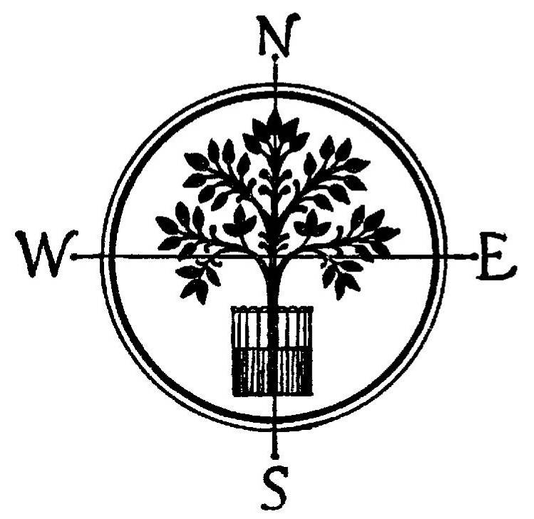

THE WARWICK SOCIETY
from the Chairman, 4 St John's WARWICK CV34 4NF
01926 498381 / 07760 287927
sec@warwicksociety.org.uk

David Barber
Development Policy Manager
Warwick District Council
Riverside House, Milverton Hill
Leamington CV32 5QH
27 July 2012

1 Introduction
1.1 In its document Local Plan Preferred Options, May 2012, at para 3.3, the Council invites the views of all interested parties to help shape a draft Local Plan.
1.2 Here are the views of The Warwick Society. They refer to the Full Version of the Preferred Options and in some cases to some of the supporting documents made available on the Council’s website. The Response Form, which we have not found effective for structuring our comments, uses the words ‘support or object’ rather than the Preferred Options’ ‘the Council is keen to hear the views’. While we have phrased our comments as views, it will be clear that many would be objections to firmer proposals, and will become formal objections if the next stage of the plan-making process does not respond satisfactorily to them.
1.3 The Warwick Society, the town's civic society, was founded in 1951, and has as its first aim to conserve, for the benefit of the public, or to encourage the conservation of, the natural, artistic and cultural amenities of Warwick and its neighbourhood. It seeks to improve standards of new development to benefit both the setting of the old buildings and the life of the town and its people.
1.4 Warwick is no stranger to development. The mediæval town was largely destroyed by fire in 1694, though many timber-framed buildings at its fringes survived. Rebuilding followed a plan to widen the streets and to improve fire-resistance with stone and brick walls. It took place at the start of the Georgian era. So the High Street, the Cross, Church Street, St Mary's Church and Northgate Street form an elegant and coherent architectural ensemble. It is the juxtaposition of the mediæval with the Georgian which makes Warwick distinctive. More recently, C19 industrial development based on the canal and then the railway has been followed by more extensive C20 sprawl based on the car and the road network. In the decade 2001-2011, the population of Warwick grew from 23,000 to 30,000, a rate of increase of 30%, among the very fastest rates of any town in the UK. Assimilating this growth and building new communities takes a generation.
1.4 The new Local Plan gives a new opportunity to make the town, and the district around it, a finer place, and a better place to live, be educated, and to work in. Its population may grow, because it is attractive, and well-located at the south-eastern corner of the West Midlands. Its future residents, and those who work here or visit, need a vision which ensures that it continues to be attractive, and to function well.
1.5 This means:
1 Developing the local economy sustainably, both facilitating growth in jobs and income and reducing the impact of climate change;
2 A pattern of development which reduces dependence on the car, congestion and pollution;
3 Transport and social infrastructure which enables people to live sustainably and economically;
4 Walking routes, cycle routes, schools, health centres and shops which allow people of all ages and capabilities easy and healthy access to them;
5 A mix of housing which meets local needs, especially affordable housing for families;
6 A rate of development which allows the towns and their communities to absorb change and make each a socially and personally contenting place to be; and
7 Protecting the natural and historic environment, especially the green hinterland of towns, green spaces within them, and the historic buildings which make them special places.
1.6 The Preferred Options fail by a long way to achieve this. The Issues [para 4.8] identified in the earlier consultation correspond quite closely to those that we have emphasised. But the preferred options focus heavily on growth and new development, disregarding the relatively low priority given to them by those who responded to the earlier consultation, and disregarding the negative effects of excessive growth and development on the matters that residents consider important.
1.7 In the following sections, we consider the three main ways in which the preferred options fail to meet the expectation of those who live in the District, and suggest changes which, if introduced to the draft Local Plan, could make it a very much better direction for the District to follow.

2 Population Growth and the Demand for Housing
2.1 The Preferred Options’ emphasis on growth in jobs and housing, each matching the other [para 4.10], is founded on a circular argument and on mere assumptions.
2.2 The Strategic Housing Market Assessment [para 5.13] ‘projects’ (not forecasts) future growth in the District’s population. It explains [SHMA figs 2.13 and A2.4] that ‘in-migration’ has been much the most important cause of population growth in the fifteen years 1996-2010. Of a total population increase of 18.9k (from 119.8k to 138.7k), 16.5k has been net in-migration, and only 2.4k the natural change. The report notes [para 2.33] that ‘past migration trends will have been influenced in part by past levels of housing delivery.’
2.3 The SHMA assumes the average rate of in-migration of the last five of those fifteen years, 2006-2010, and projects it for the next twenty. There is no quantified analysis of the causes of the in-migration, nor any quantified forecast of its future level. It is simply an assumption.
2.4 The SHMA goes on to assume an age profile for the in-migrants, again basing its projection on neither evidence nor analysis, but on assumptions, in this case those of the ONS [SHMA para 2.17]. The projection of net in-migration is the difference between two much larger numbers, gross in-migration and gross out-migration, and the in-migration figure is produced only by adding that assumed net projection to the ONS assumption of out-migration. The projection is not a forecast, just an arithmetical exercise, and its predicted growth in population is no more solid than the assumptions and extrapolations on which it is based.
2.5 The extrapolations have as their base the after-effect of rapid housebuilding in the years before the market collapsed in 2008. All that they show - as described at the end of para 2.2 above - is that if houses are built, people will move into them; in a second circularity, if the mass housebuilders do not believe that their output will be sold, they build little. A third circular argument then enters the Plan as it stands: if the population rises, employment will rise, as those who buy and occupy the new houses are very likely to have jobs - without which they do not have the means to buy the houses.
2.6 We conclude that the preferred level of 'growth' is simply a bid for growth, rather than a forecast for which there is either evidence or action plan, other than almost free-for-all development with all of the negative impacts on existing residents and the environment that that will bring. The alternatives of more modest levels of growth, in both housing and employment, with much lower damaging impacts, would be equally valid for the Council to choose. We urge that it should reconsider its preference in the light of the absence of evidence in support of it, and take a broader view of both growth and all its consequences.

3 Infrastructure
3.1 The infrastructure proposals do not provide for sustainable development. The modelling of the existing network against possible locations for development consists only of modelling vehicle flows. It does not reflect the national polices and Local Transport Plan which require priority to be given to reducing the demand for transport, and to walking cycling, and public transport.
3.2 Except for the possibility of Kenilworth station (which would have a negligible impact on demand for road use in the peaks) all of the significant infrastructure proposals are for increases in the road network. They have been selected to deal with some of the local congestion created by increase in demand of the various housing site options. They do not provide a coherent transport network for Leamington, Warwick and Kenilworth, rather a continuation of the existing mismatch between traffic and the capacity available to accommodate it.
3.3 Good railway services are already provided at Leamington and Warwick Parkway stations. The level of service at Warwick station is significantly inferior to that of Warwick Parkway, even though it serves a much more substantial population within walking distance. Conversely, almost all access journeys to Warwick Parkway are by car. For journeys to and from work, Birmingham and London are significant destinations and there is some commuting in to Warwick and Leamington which is badly served by Warwick Parkway. The basis of a sustainable infrastructure plan should be to improve train services at all three of these stations, and especially at Warwick station, and to concentrate development close to them, minimising car use. This possibility does not appear to have been considered.
3.4 The conclusion of the modelling is that the existing level of congestion on the urban road network in Warwick, and elsewhere, will be worse than now for longer each day. No attention has been given to the requirement to reduce the impact of traffic on Warwick town centre, in particular to meet the Air Quality Management Area requirement to reduce the level of noxious emissions. This failure invalidates the infrastructure plan. The health of residents, as well as the town centre economy and the conservation of its historic buildings all require that the legal requirement to restore air quality should be given absolute priority.
3.5 Instead, the infrastructure plan proposes spending almost all of the potential developers' funding contributions on major expansion and 'improvement' of the road network. The lesson was learned decades ago that changes of this kind, increasing capacity on some congested sections, simply increases congestion on adjacent parts of the network, through the traffic that the improvements generate.
3.6 We are disappointed and concerned that the preferred options do almost nothing to allow transport demand to be met more sustainably, rather simply try to accommodate it at the expense of the environment and of existing residents and road users. We consider that the whole emphasis of the plan should be above all on sustainability of transport, not just for its environmental impact but also because the prosperity of residents of the district depends on accessibility to services without having to meet the increasing costs of car use.

4 Locations for Development
4.1 Much of the criticism of the Preferred Options has been directed towards the allocation of particular areas of greenfield land at the fringes of the urban area on which large-scale house building is proposed. These sites represent a major misdirection of development. We consider that, rather than the strategy of the Preferred Options, the pattern of development in the district should be dramatically different.
4.2 The total level of development should be substantially lower, of the order of 250 dwellings per annum, Option 1, which is sufficient to meet local needs and not to encourage in-migration.
4.3 Unbuilt existing permissions themselves provide nearly five years' supply to meet this level of requirement.
4.4 Beyond these absolute priority should be given to brownfield sites, as provided for by the NPPF. The Preferred Options propose only that brownfield sites should be used at the end of the plan period, the effect of which would be to consume greenfield sites rather than to bring forward brownfield sites by increasing their value. Some brownfield sites may provide for small numbers of dwellings, but these should not be dismissed: there are potentially many of them.
4.5 Brownfield development should include the intensification of existing development within the urban areas. We do not rule out 'garden development', which can often be in locations close to existing facilities and employment and easily served sustainably. There are extensive areas of development carried out mainly in the second half of the twentieth century where more intensive use of existing housing and employment land would be entirely feasible - were the market signals to encourage it. The proposals for much more intensive office use of the IBM/Opus 40 site on the north-west edge of Warwick go too far in this direction, but demonstrate that intensifying development on a site well connected to the transport network can be attractive to developers.
4.6 Only as a last resort should greenfield land be allocated. The suggestion that it can produce high-quality environments by applying the principles of the garden cities is spurious. The garden cities were planned around local employment and services (in the era before the car, competing supermarkets, choice of school admissions, and two-income households became the societal norm): that is not how we live now. All of the greenfield sites at the urban fringe would be largely car-dependent. As well as their damaging impact on infrastructure and on existing settlements, they would not produce stable, happy communities of their own. The rapid growth in population of Warwick in the last decade requires a period of much gentler growth while the new communities gel.
4.7 The allocation of land south-east of Warwick between the Banbury Road and Europa Way does exactly what the Preferred Options say that they wish to avoid, merging the built-up areas to their east and west. The northern part, north of Gallows Hill, would make Warwick, Leamington and Whitnash into a continuous, sprawling urban area. The southern part, between Europa Way and the Banbury Road would extend this sprawl beyond the natural existing edge of the built-up area, taking development over higher ground and visible from long distances. It would have a directly damaging effect on Castle Park, Grade 1 registered landscape.
4.8 The Green Belt was established to end the outward sprawl of the major conurbations. Circumstances change and there may be exceptional reasons for declassifying Green Belt land: the expansion of Warwick University may be a virtuous case of this. But it is essential that its edges should not be eaten into by extending urban sprawl, for example at Loes Farm and north of Leamington, in the opposite direction from that which it was originally intended to prevent. Similarly, when the Green Belt was designated land south of Warwick and Leamington was not seen as threatened by sprawl from the conurbation simply because the towns stood in the way. Now, that land requires the same level of protection as the post-war Green Belt gave to the edge of the Birmingham and Coventry built-up areas.
4.9 Instead, the Green Belt has become the guarantor of favourable surroundings for the few residents in and outside villages scattered across it. Given the severe damage to the existing urban areas that would follow from their outward extension, an entirely different approach is required to find acceptable greenfield sites. The possible 'Gateway' development around Coventry Airport is an example of this approach: it must concentrate employment and housing close to good transport links without creating undue pressure on the existing urban areas. Planned new or enlarged settlements outside Warwick, Leamington and Kenilworth, and in some cases outside the district - delivered through cooperation with neighbouring authorities - should also be preferred. The substantial employment at Gaydon is not matched by housing provision in the locality, rather met by car-borne commuting to it. Warwick Parkway station and the nearby A46 provide an opportunity not for an urban extension but for a new settlement outside the existing urban boundary, which would not damage what lies within it. Hatton and Lapworth, with existing railway stations, could also be the focus of much more extensive development than is proposed.

5 Conclusion
5.1 We have concentrated on the three main ways in which the preferred options would both worsen the quality of life of the district's residents and damage the historic environment.
5.2 In the copious supporting documentation, there are many more details of the proposed policies which we cannot support.
5.3 But we have limited our comments to these three main issues to try to persuade the Council that the eventual draft Local Plan must be very different from the Preferred Options now proposed.
5.4 We urge the Council to reconsider its preferences and to recognise its long-term responsibility to both the environment and the quality of life of Warwick district.

James Mackay,
Chairman

Though the document itself does not have this title, it is referred to by it in the abbreviated booklet given wider circulation.
[para 2.34] ‘Our main trend based migration assumption therefore assumes ... ’

